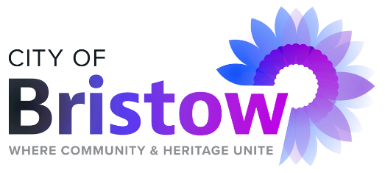
Municipal Authority
of the City of Bristow

_____________________________________________________________________________________________
MUNICIPAL AUTHORITY MEETING AGENDA
BRISTOW CITY HALL
110 WEST 7TH, BRISTOW, OKLAHOMA 74010
FEBRUARY 5, 2024 ( MONDAY )
IMMEDIATELY FOLLOWING THE BRISTOW CITY COUNCIL MEETING AT 7:00 P.M.

Official action can only be taken on items which appear on the agenda. The Trustees may adopt, approve, ratify, deny, defer, recommend, amend, strike, or continue any agenda item. When more information is needed to act on an item, the Trustees may refer the matter to the Chairman or the Trust Attorney, or back to a committee or recommending body. Under certain circumstances, items may be deferred to a specific later date or stricken from the agenda entirely.
- Call to order

- Roll call.

- Approval of the Municipal Authority Regular Meeting Minutes: January 16, 2024.

- Consideration, discussion, and possible approval of the Consent Agenda:

  - Approval of Maintenance Claims in the amount of $58, 834.25.

  - Approval of Unpaid Claims in the amount of $1,750.00.

  - Approval of Actual Payroll Claims in the amount of $17,311.34, for pay period ending January 19, 2024.

  - Approval of Actual Payroll Claims in the amount of $19,367.10, for pay period ending February 2, 2024.

  - Approval of Estimated Payroll Claims in the amount of $19,361.90, for pay period ending February 16, 2024.

  - Approval of a budgeted transfer in the amount of $50,000.00 from the Municipal Authority General Fund to the City General Fund.

BRISTOW MUNICIPAL AUTHORITY MEETING CONT.
FEBRAURY 5, 2024 ( MONDAY )

PAGE 2

  - Approval of Claim #20800 to Holloway, Updike and Bellen, Inc. In the amount of $17,500.00, Engineering Services on the Northside Development project (paid from OWRB-Northside).

- Comments from Chairman and Trustee.

- Adjourn.

DATE POSTED: FEBRUARY 1, 2024
TIME POSTED: 3:00 P.M.
POSTED BY: SABRINA MOUNCE

